USER – INTERFACE MAGIC

1. when to use require() and when define()? Difference between require and define.

Ans:

It is a functionality of requiresJS. With define we are registering a module in require.js that can depend on in other module definitions or require statements. With require we "just" load/use a module or javascript file that can be loaded by require.js for execution.

***Example:***

***main.js*** *:*

*/**  
 * Created by Priyanka Acharya on 5/8/15.  
 */****require***([**"jquery"**,**"employeeManager"**,**"archieve/employeeData"**], **function** ($,employeeManager,employeeData) {  
 alert(**"main.js funtion"**);  
 **var** main= employeeManager.loadEmployeeData();  
 alert(**"main.js end"**);  
  
 **return** main;  
})  
  
In the above code main.js we are using this module for execution and calling loadEmployeeData(); which is available in **employeeManager** module and we are not using this module anywhere in code.

***employeeManager .js***

*/**  
 * Created by Priyanka Acharya on 5/8/15.  
 */*

***define([”jquery”,”build/myHandleBar”], function($,handlebars) {  
 var Employee_METHOD ={  
 handlerData:function(resJSON){***

***$(‘#mydiv’).html(handlebars(resJSON));  
  
},  
loadEmployee : function(){***

***$.ajax({***

[***url:"http://localhost:63342/NewnodeJsProject/public/data/studentData.json",***](url:%22http://localhost:63342/NewnodeJsProject/public/data/studentData.json%22,) ***method:’get’,  
 success:this.handlerData***

***})  
 }  
 };  
return Employee_METHOD;***

***});***

In this case a module has been created using define Specifying the dependencies and it is getting used in main.js .

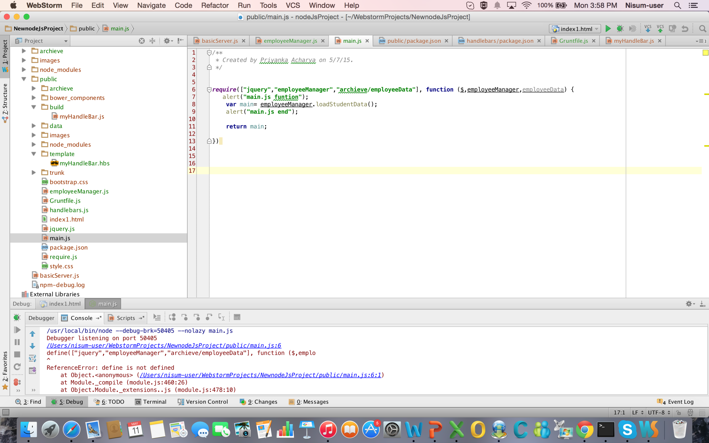

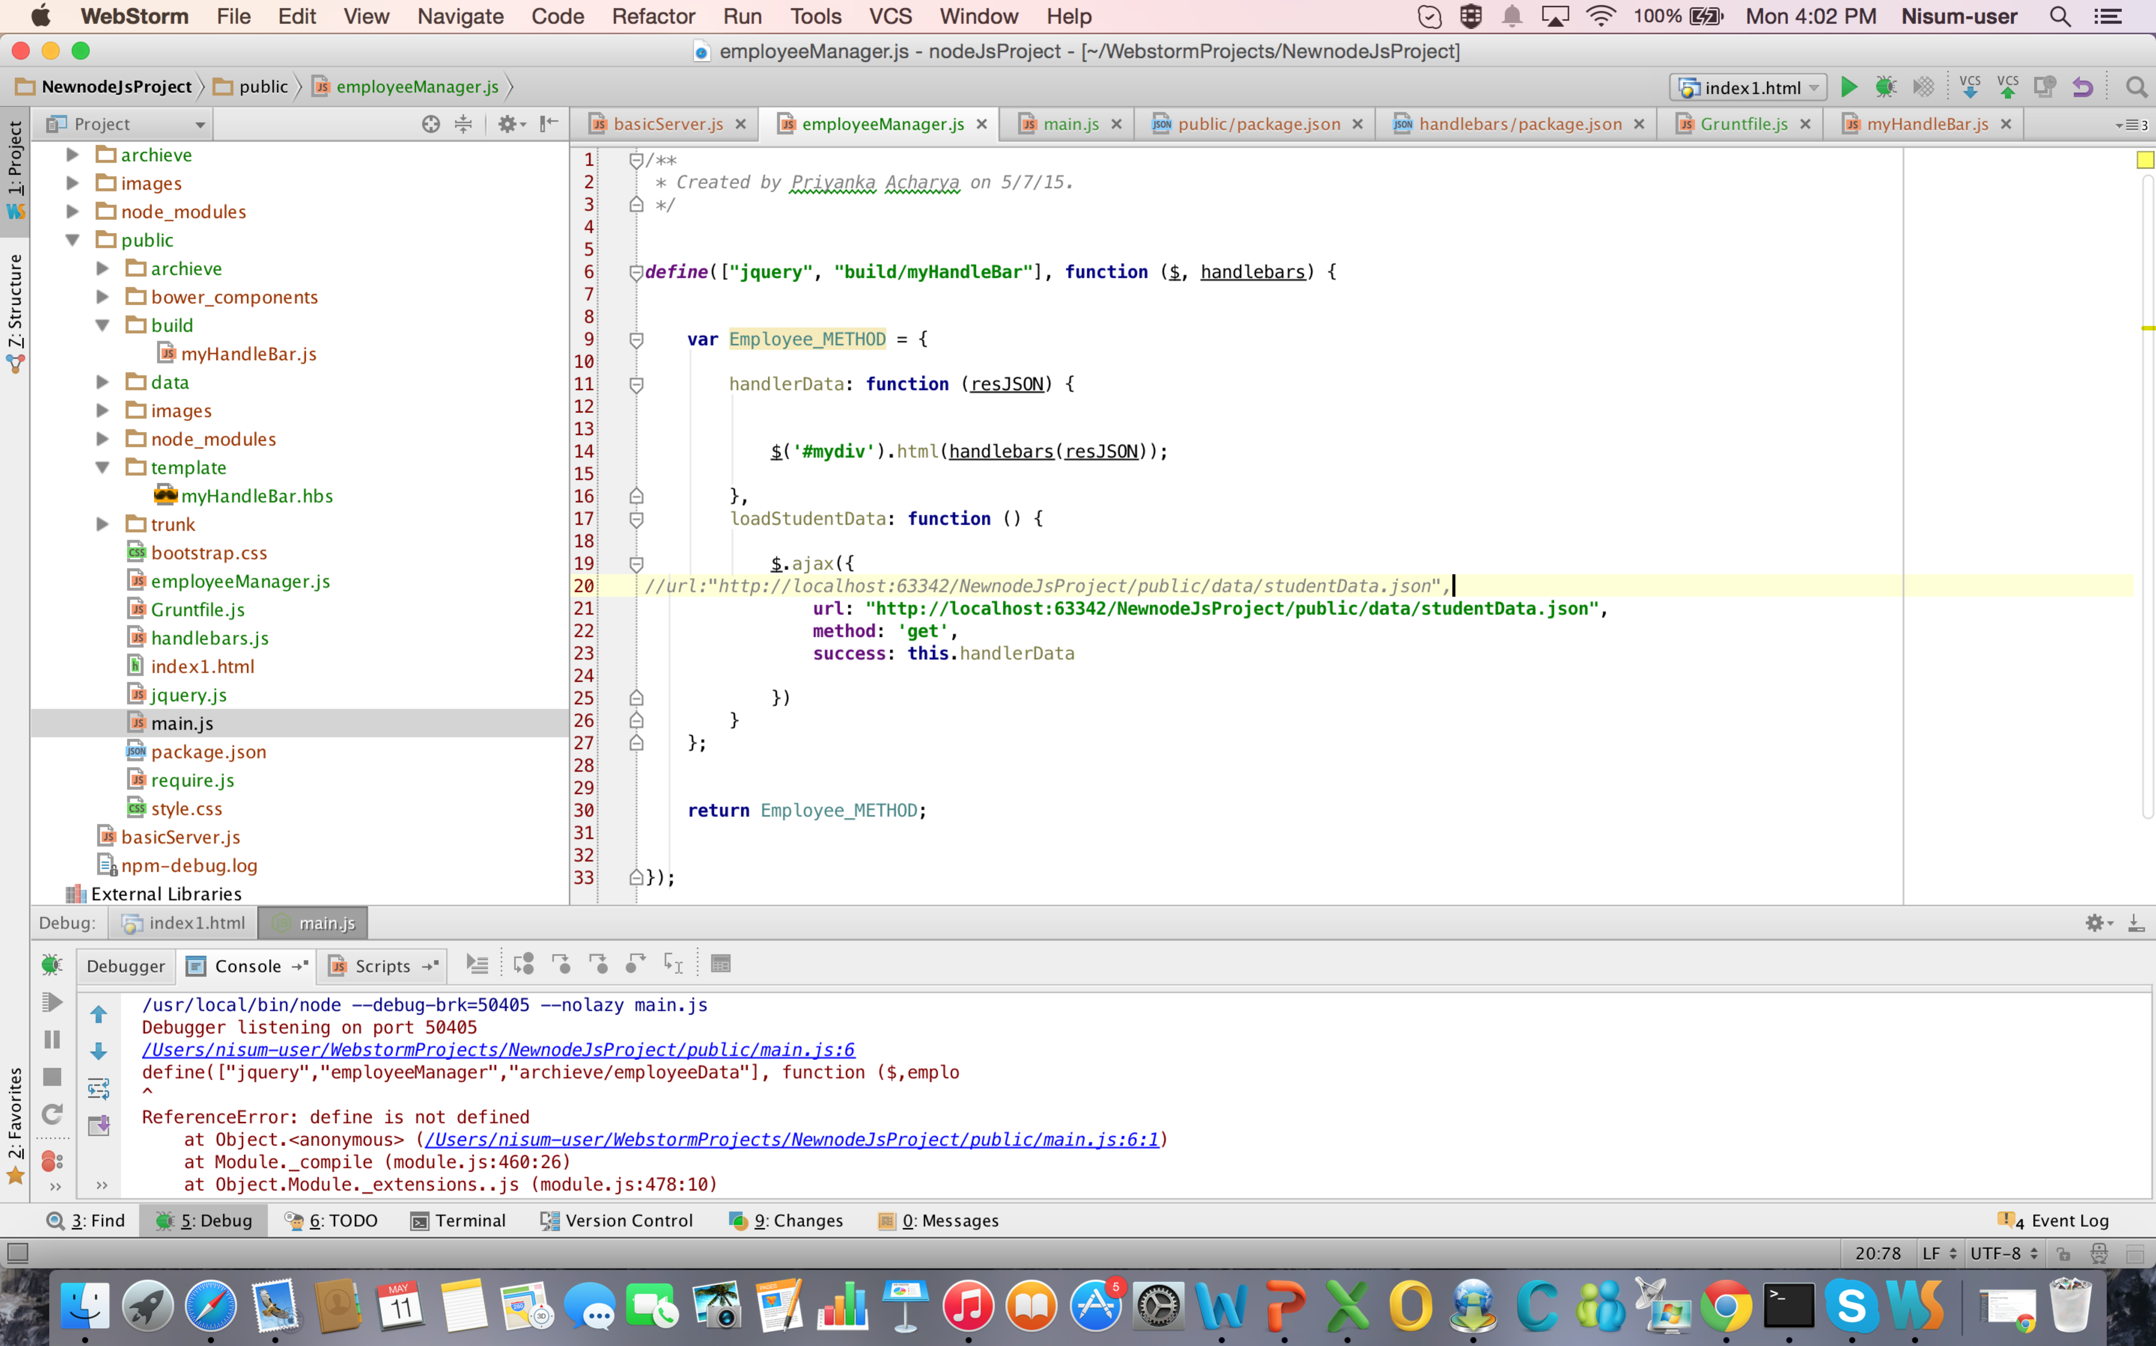

**Difference:**

The **define()**function accepts two optional parameters (a string that represent a module ID and an array of required modules) and one required parameter (a factory method).

The return of the factory method **MUST** return the implementation for your module (in the same way that the [Module Pattern](http://addyosmani.com/resources/essentialjsdesignpatterns/book/#modulepatternjavascript) does).

The **require()** function doesn't have to return the implementation of a new module.

Using **define()**you are asking something like *"run the function that I am passing as a parameter and assign whatever returns to the ID that I am passing but, before, check that these dependencies are loaded"*.

Using **require()**you are saying something like *"the function that I pass has the following dependencies, check that these dependencies are loaded before running it"*.

The **require()**function is where you use your defined modules, in order to be sure that the modules are defined, but you are not defining new modules there.

1. How to use handlebars? How to compile, how to execute.

Handlebars templates look like regular HTML, with embedded handlebars expressions. Written in JavaScript, Handlebars.js is a compiler that takes any HTML and Handlebars expression and compiles them to a JavaScript function. This derived JavaScript function then takes one parameter, an object—our data—and it returns a string with the HTML and the object properties’ values inserted into the HTML. So, we end up with a string that has the values from the object properties inserted in the relevant places, and insert that string as HTML on the page.

The following example shows how to compile and execute handlebars.JS

I am basically building a small app, which will read values from a json file and display it with the help of handle bar.

The Basic App:

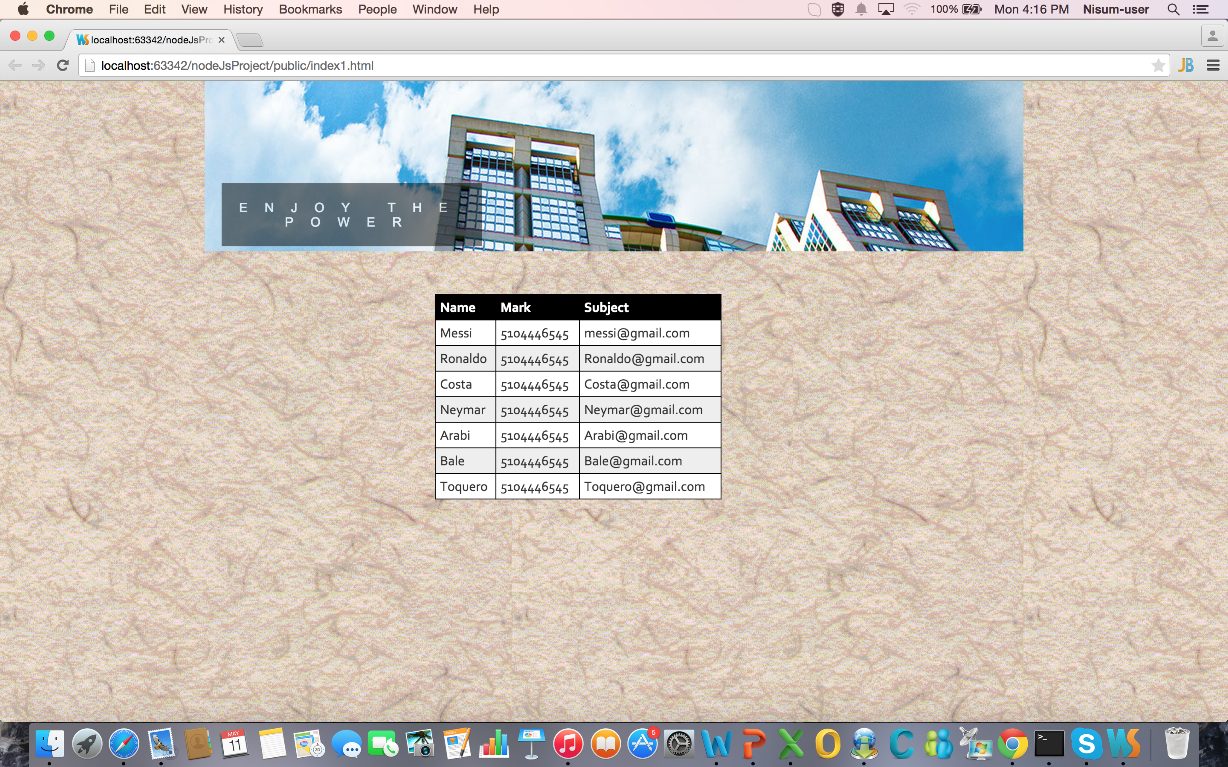

in index.html:

<body>

<div id="banner"><p>Enjoy the Power</p>

</div>

<br><br> <br><br><br>

<div id="mydiv" > </div>

<!--Handlebar templates start-->

<script id="employee-template" type="text/x-handlebars-template">

<table id="t01">

<thead>

<tr>

<th>Name</th>

<th>Email</th>

<th>Phone</th>

</tr>

</thead>

<tbody>

{{#each employeesArray}}

<tr>

<td>{{ this.name }}</td>

<td>{{ this.phone }}</td>

<td>{{ this.email }}</td>

</tr> {{/each}}

</tbody>

</table>

</script>

<!--Handlebar templates end-->

</body>

</html>

Basically from the script id= employee-template handlebars is getting initiated and now lets take a look at employeeManager.js file

/** Created by Priyanka Acharya on 5/7/15. */

define([”bower_components/jquery/dist/jquery”,”bower_components/handlebars/handlebars”],function ($,handlebars) {

var Employee_METHOD ={

handlerData:function(resJSON){

var templateSource = $(“#employee-template”).html(),

template = handlebars.compile(templateSource),

studentHTML = template(resJSON);

$(‘#mydiv’).html(studentHTML);

console.log($(“#employee-template”))

},

loadStudentData : function(){

$.ajax({

[url:"http://localhost:63342/NewnodeJsProject/public/data/studentData.json](url:%22http://localhost:63342/NewnodeJsProject/public/data/studentData.json)”, method:’get’,

success:this.handlerData

})

}

};

return Employee_METHOD;

});

now in employeeManager.js file we are compiling the script using handlebars and then looping through the values.